- Write a blog on Difference between HTTP1.1 vs HTTP2
- HTTP2 is much faster and more reliable than HTTP1.1
- HTTP1 loads a single request for every TCP connection,while HTTP2 avoids nerwork delay by using multiplexing.
- In HTTP/1.1, flow control relies on the underlying TCP connection.HTTP/2 multiplexes streams of data within a single TCP connection.
- In HTTP/1.1, if the developer knows in advance which addirional resources the client machine will need to tender the page,they can use a technique called resource inlining to include the required resource directly within the HTML document that the server sends in response to the initial GET request.For example, if a client needs a apecific CSS file to render a page, inlining that CSS file will provide the client with the needed resource before it asks foe it, reducing the total number of requests that the client must send.
- Since HTTP/2 enables multiple concurrent responses to a client’s initial GET request,a server can send a resource to a client along with the requested HTML page, providing the resource before the client asks for it. This process is called server push.In this way, an
HTTP/2 connection can accomplish the same goal of resource inlining while maintaining the separation between the pushed resource and the document. This means that the client can decide to cache or decline the pushed resource separate from the main HTML document, fixing the major drawback of resource inlining
- Programs like gzip have long been used to compress the data sent in HTTP messages, especially to decrease the size of CSS and JavaScript files.
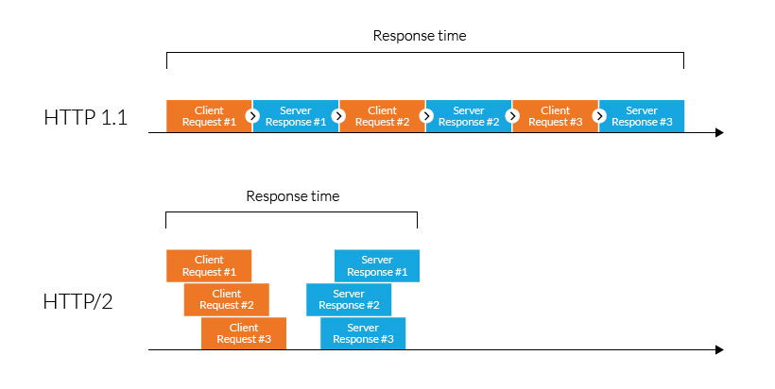
- One of the themes that has come up again and again in HTTP/2 is its ability to use the binary framing layer to exhibit greater control over finer detail.

